BIBLE BUSINESS

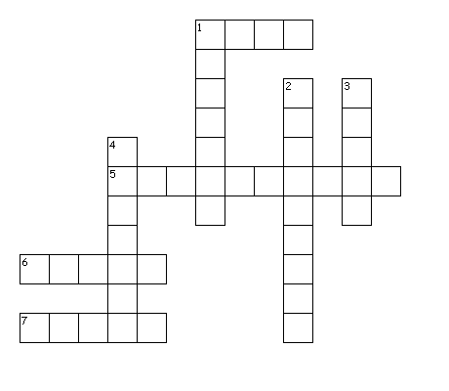

Across
1. shortest Gospel
5. last book
6. not by ___
7. Mark and Luke do not include the ______ of Christ

Down
1. tax collector
2. books in the Bible
3. king who hated Jesus
4. Jesus said a ___ is not accepted in his own hometown

