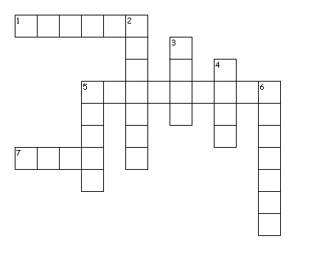
Pentecost and Power
Across
1. God is---
5. found in Acts 2
7. author of Acts
Down
2. "God in three persons"
3. Prophet quoted during Pentecost
4. pure/sacred
5. preached church's first sermon
6. languages

