The “I Am” Declarations of Jesus
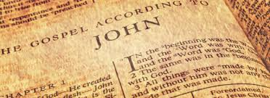
According to the Gospel of John
(some versions list 8)

- 6: 35, 48, 51 – Bread of Life
- 8:12 & 9:5 (not combined in all lists) – Light of the World
- 10:7 – Gate for the Sheep
- 10:11 – Good Shepherd
- 11:25 – Resurrection and the Life
- 14:6 – The Way, Truth
- 15: 1, 5 – True Vine

These statements refer to the metaphorical depictions of Jesus as he communicated with his listeners, followers and disciples.

