John at the Cross of Jesus
John 1925b-27(NRSV)

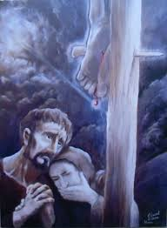
Meanwhile, standing near the cross of Jesus were his mother, and his mother’s sister, Mary the wife of Clopas, and Mary Magdalene. ²⁶ When Jesus saw his mother and the disciple whom he loved standing beside her, he said to his mother, “Woman, here is your son.” ²⁷ Then he said to the disciple, “Here is your mother.” And from that hour the disciple took her into his own home.

Putting It in Context
- Why we believe the “one whom Jesus loved” is John
- All of the other disciples had scattered
- Mary was most likely widowed and living alone
- Jesus thought of his mother
- Jesus trusted his disciple

Questions to consider
- Could it be that just as Judas was sent to betray Jesus, John was sent to be his beloved brother in ministry?
- Where was John standing at the cross?
- What does this suggest about his character or frame of mind at the time?
- Why did John not run away as the other disciples did? What is the lesson for us as disciples of Jesus?

