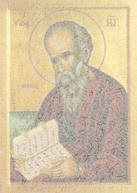
John the Apostle
Facts from the Bible

- John was the younger of the sons of Zebedee and Salome See Matthew 4
- A cousin to Jesus; his mother was Mary’s sister See Matthew 27, Mark 15
- He is believed to be the “one whom Jesus loved” See John 21
- The only disciple who did not forsake Jesus at the Cross See John 19

Other Facts:
____________________________________________ Text:
_____________________________________________ Text:
____________________________________________ Text:
_____________________________________________ Text:

Notes:
__________________________________________________________________________________________________________________________________________

Fall 2016 BBAMEC

