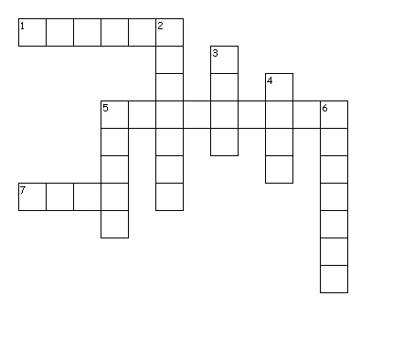
Pentecost and Power
Across
1. God is--- Spirit
5. found in Acts 2 - Pentecost
7. author of Acts - Luke
Down
2. "God in three persons" - Trinity
3. Prophet quoted during Pentecost - Joel
4. pure/sacred - holy
5. preached church's first sermon - Peter
6. languages - Tongues

